Hawthorne Elementary
2023-2024
1st Grade School Supplies

The following list contains supply items that will be needed by the student during the year:
- **Headphones (labeled with name)
- **2 primary marble composition notebooks (labeled with name) (Room to draw on top half of each page, handwriting lines to write on the bottom of each page)
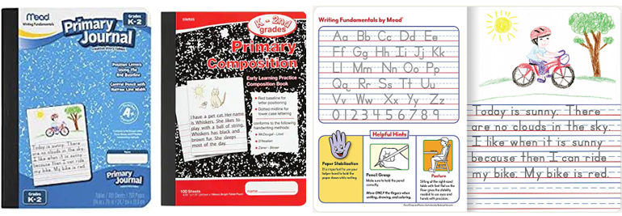
- 1 wide ruled marble composition notebook (labeled with name)
- 2 PLASTIC folders (labeled with name)
- Zip pouch pencil case (labeled with name)
- 1 pair of scissors (labeled with name)
- 1 pack of crayons
- 12 sharpened #2 pencils
- 1 pack of black dry erase markers
- 2 large erasers
- 8 glue sticks

Families may donate the following school supplies:
- Tissues
- Ziploc Bags (gallon, quart, or zipped sandwich sizes)
- Hand Sanitizer
- Cleaning Wipes

